MC900290671[1]

**ZVONEČEK**

**Lazar a boháč**

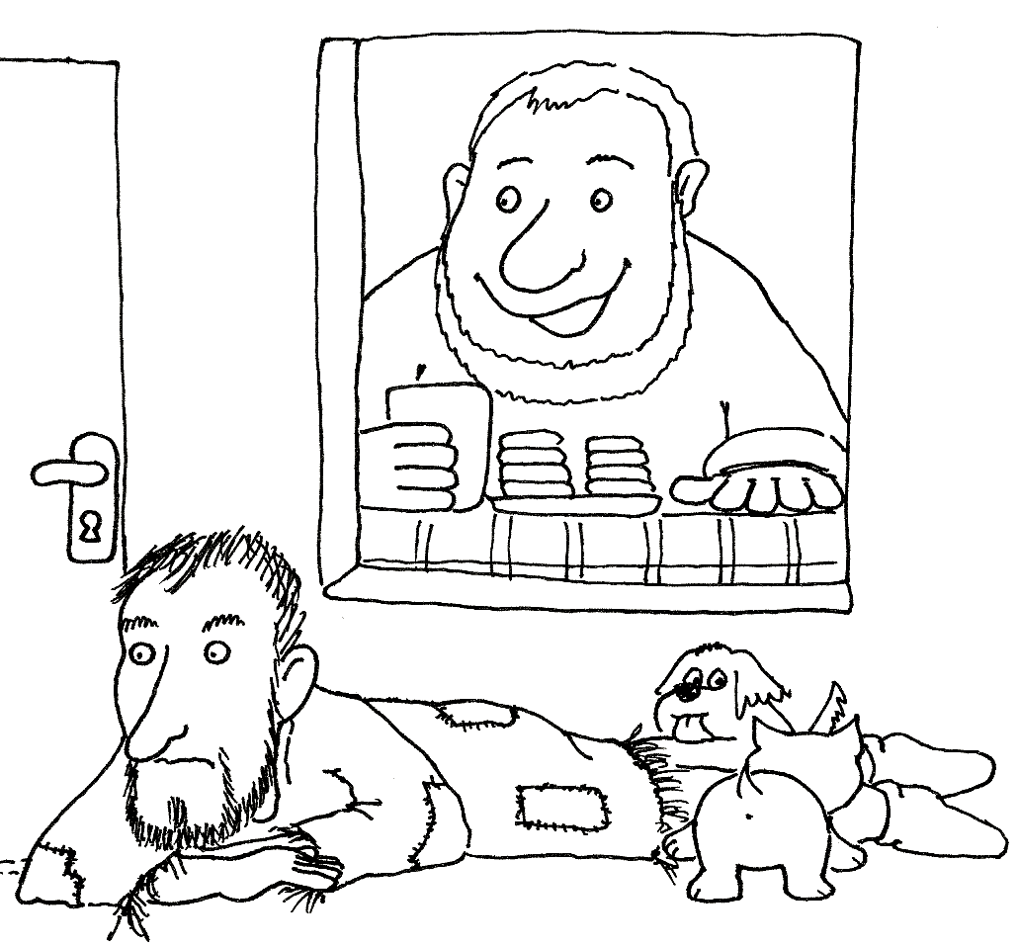

**MC900290671[1]**

**ZVONEČEK**

**Lazar a boháč**



